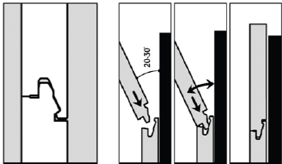

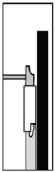

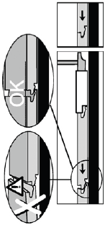

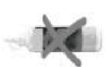

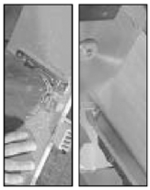
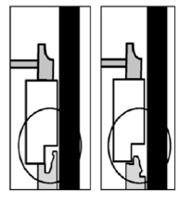

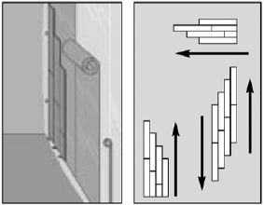

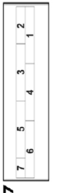

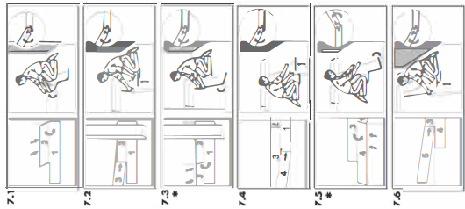
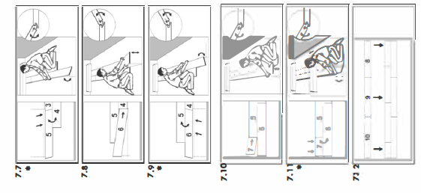

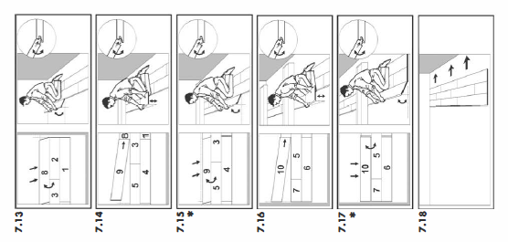

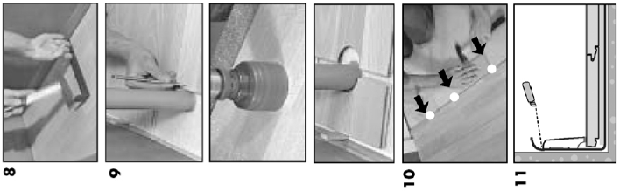

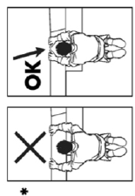

- The UNICLIC-system is a patented system for installing Linia-Eco wooden floors without glue.
Linia-Eco wooden flooring is not suitable for use in humid areas such as bathrooms, saunas, etc.
Check the contents of all packages before and during the installation. Floorboards with visible defects may not be installed.
Floorboards with the UNICLIC system can be installed in 2 different ways:
- The floorboards can be rotated to fit into each other (tongue into groove, or groove into tongue). However, the easiest way is to fit the tongue into the groove. (The following installation instructions are based on using this installation technique as much as possible. Installing the groove onto the tongue is only neces­sary in a few specific cases). Position the floorboard to be installed at an angle of 20-30° to the board that has already been installed. When fitting the floorboard, move it upwards and downwards slightly, and push it forwards at the same time. The floorboards will then click into place.

- In some cases, the floorboards cannot be rotated when they are installed, for example, underneath a doorframe. In this case, the floorboards can also be installed flat.

IMPORTANT! For this, you require a hammer and a flooring tapping block. NEVER USE A DIFFERENT TYPE OF TAPPING BLOCK. This could cause damage to the floorboards when they are installed. You should not attempt to knock the click joint into place with a single hit. For the short edge, you must tap several times until the floorboards click together completely. For the long edge, you must work gradually: you start tapping gently at the corner of the floorboard until the joint has closed and repeat this action every 30cm until the entire long side of the floorboard has clicked together completely.

- In addition to the traditional tools for installing wooden flooring, such as a hammer, saw, crowbar or pinch bar with a protruding edge (to be tapped on with the hammer), and spacer blocks (8-10 mm), it is imperative to use a Flooring Tapping Block when installing the floor. If you use any other type of tapping blocks, you will certainly cause damage to the floorboards during installation. When shortening the floorboards, use a fine-toothed hand saw, a jigsaw or a crosscut saw. To achieve a clean cut, when using a jigsaw, you must ensure that the patterned side is underneath, and when using a hand saw or a crosscut saw you must ensure that the patterned side is on top.

- The floor should preferably be installed so that the incoming light is parallel with the floorboards. The ideal conditions are 15-20° C and a relative humidity of 50-60% Check that:
- the doors can still be opened and closed after installing the floor with minimum 10mm gap.
- the doorframes may have to be adapted in order to install the floor underneath them.

- The base must be perfectly clean and flat before any floorboards are installed on top of it. Any unevenness of more than 2mm per meter must be removed. Depending on the situation, the following cases are possible:
  - New Concrete. The moisture content of the concrete must be less than 2.5 % (CM method). A freshly poured cement screed (topping) must dry for at least 1 week per cm of thickness up to 4 cm, and for 2 weeks per cm of thickness above 4 cm, and be adequately ventilated. (A 6 cm thick topping must therefore dry for at least 8 weeks). The moisture content of an anhydrite floor may not exceed 0.5%.
  - In the case of under floor heating, the moisture content must be less than 1.5 % (CM method). In this case, special installation instructions are applicable. See special section below.
    - Renovated construction. In the case of a damp-proof floor covering (PVC, linoleum, etc), Linia-Eco may be installed on the existing floor covering.
    - In the case of a moisture-open floor covering (carpet, needled felt, etc). The existing floor covering must first be removed.
  - Wood Floor. First remove any existing floor covering. The wooden floor must be sufficiently stable. Any loose parts must be nailed down and, if necessary, a levelling compound must be installed.
    - The moisture content of the wood must not exceed 10 %. The creeping space underneath the wooden floor must be adequately ventilated: first remove any obstacles and provide adequate ventilation (minimum of 4 cm2 total ventilation holes per m2 floor).
    - Install the new Flexura- floorboards across the old boards.

- Wood is the primary constituent of FLEXURA floorboards. Since the humidity can vary in a room due to seasonal differences, e.g. between summer and winter, it is imperative that the floor can expand in all directions. This expansion can be as much as 2 mm per meter. The larger the surface, the more space is required for expansion. ALL the sides of the floor must be able to expand or contract. To enable this, an expansion gap of at least 8 to 10 mm must be allowed for at the walls. This expansion gap must also be allowed for around pipes or thresholds. In the case of larger surface areas, a wider gap must be allowed for, e.g. underneath a double wall. Take account of the fact that the floor may move in one direction. Wherever possible, provide expansion gaps, e.g. underneath doors. These expansion gaps are covered by a profile that is not secured to
the wooden flooring, but to the base floor. It is preferable to install the floorboards in the same direction as the longest wall, so that the incoming light is parallel with the floorboards (visually more attractive). You can start installing the floor in one corner or in the middle of the room. You can also work from left to right, or from right to left.
Always remember that the 'tongue-in-groove system" is the easiest way method of installation.

- Always ensure that there is a 10 mm expansion gap between the final row and the wall. When doing this, remember that you have to saw off the long edges of the final row of floorboards.

Install these floorboards one at a time next to the boards of the penultimate row and tap the long edges together using the pinch bar and hammer. Use the wooden floor tapping block to tap the short edges together.

- Ensure that in the row where there is a pipe, the pipe is positioned exactly at the transverse joint of two floorboards. Take a drill bit that has the same diameter as the pipe+ 20 mm for the expansion. Click the floorboards together at the short edge and drill the hole so that the centre of the hole is positioned where the two floorboards join. Now install the floorboards as part of the floor.

- Saw the floorboards so that after they have been installed, there is an expansion gap that is at least 10 mm wide. When you cannot rotate the floorboard, use a pinch bar or tapping block and hammer to tap the boards together.

- After installing the floor, you can immediately start walking on the floor and begin finishing it off. This is one of the major advantages of the UNICLIC system.
  - Remove all spacer blocks
  - Fix the skirting boards to the plastic membrane overlapping up from the floor. Never secure the skirting boards to the floor (so that the floor can expand and contract underneath the skirting board).
  - Finish the gaps around pipes with rosettes.
  - In places where profiles or skirting boards cannot be placed, you must fill the expansion gap with an elastic filler paste.

- Precautions
  - Protect furniture and chair legs with felt or plastic caps.
  - Prevent dirt, water and sand from being brought inside by placing a mat at the door.
  - Use wheelchairs with soft wheels, suitable for hard floors.
  - Ensure that the level of humidity in the room is between 50 % and 65%. If necessary, use an adequate humidifier.

- Cleaning
FLEXURA is based on a watertight-glued HDF board that has a low level of swelling. Despite the relatively moisture-proof nature of FLEXURA floorboards, excess water must be immediately removed. WET CLEANING IS ABSOLUTELY FORBIDDEN!
- The smooth surface of FLEXURA floorboards is resistant to dust and dirt. Dry cleaning is therefore best carried out using a duster or vacuum cleaner.
- Slightly damp cleaning is possible by wiping over with clean water, or with a Woods Good Cleaning Product (Never use other cleaning products or detergents).
- Only use a well wrung-out cloth. Always wipe dry immediately until no more moisture is visible on the floor.
- Use a little methanol or methylated spirit to carefully remove stubborn stains.
- Never use any scouring products.

- Under Floor Heating. Unless otherwise expressly stated, the general installation instructions described above remain applicable. The maximum permissible thermal resistance (R) of a floorcovering on underfloor heating is 0.15 (EN4725). In this respect, take account of the sum total of the thermal resistance of all materials that are installed on top of floor heating: the floorboards themselves and all subfloors on which these are installed. The respective values for Linia-Eco floorboards and Linia-Eco underfloor are 0.075 and 0.053; total, 0.128. Provide the necessary expansion gaps. Never install lengths over 10m.
The type of cement screeding and the way in which it is applied, in combination with the floor heating, must comply with the instructions provided by the suppliers of the screeding and the floor heating. In order to obtain an even temperature across the entire floor, the distance between the heating elements may not exceed 30 cm. The heating engineer will determine the depth of the elements. The concrete floor or the cement screeding must be DRY enough (maximum 1.5%, measured using the CM method), before the floorboards can be installed.
In the case of anhydrite screeding, this value is 0.5%.
In the case of newly applied screeding, you must wait at least 21 days before switching on the floor heating. The concrete and screeding must dry without the aid of the floor heating! The water temperature may only be increased by 5°C per day over a period of 2 weeks to 50% of capacity, and to 100% of capacity during the last 2 days before installing the floor. This is also applicable during the summer! A period of at least 2 weeks must elapse between the start of the heating up period and the installation of the floor.
When starting to install the floorboards, the surface temperature may not exceed 18°C. For this, the water temperature must be decreased in maximum steps of 5°C per day until this surface temperature is reached.
In the case of a newly applied cement screeding, with regard to the starting up period, follow the guidelines stated by your heating engineer who must provide you with the completed warming-up protocol.
Also, when installing Linia-Eco floorboards on top of existing floor heating, the floor temperature must not exceed 18°C. After installing the floor, wait at least 24 hours before gradually (S°C per day) restarting the heating. The maximum permissible surface temperature of the floor is 28°C. The maximum hot water temperature is 50°C. At the start and the end of a heating period, the temperature of the water must always be increased or decreased in steps of 5°C per day.
During the heating period, it must be ensured that the relative air humidity in the rooms is not too low. At 18-22°C, the relative air humidity must be at least 50%. The use of an adequate air humidification system can help in this respect.
Always prevent the accumulation of heat due to installing carpets on the floor or not leaving adequate space between furniture and the floor. During the heating season, open joints may appear.

